Benchmark - Active Directory Lab

Ryan Coon

CYB-515

Professor Edward Marchewka

September 18, 2024

Part 1:

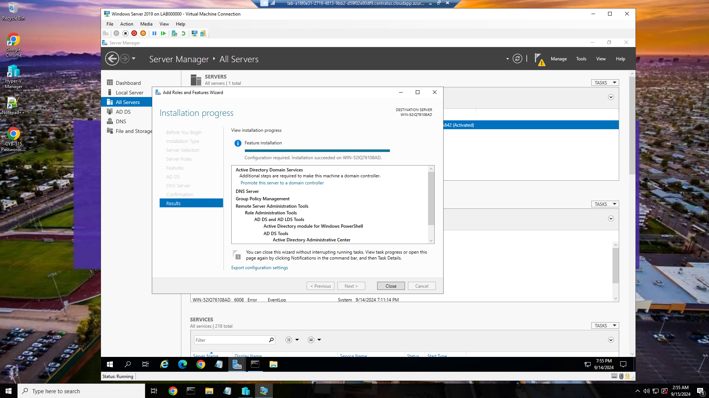

Installation of AD onto Windows server

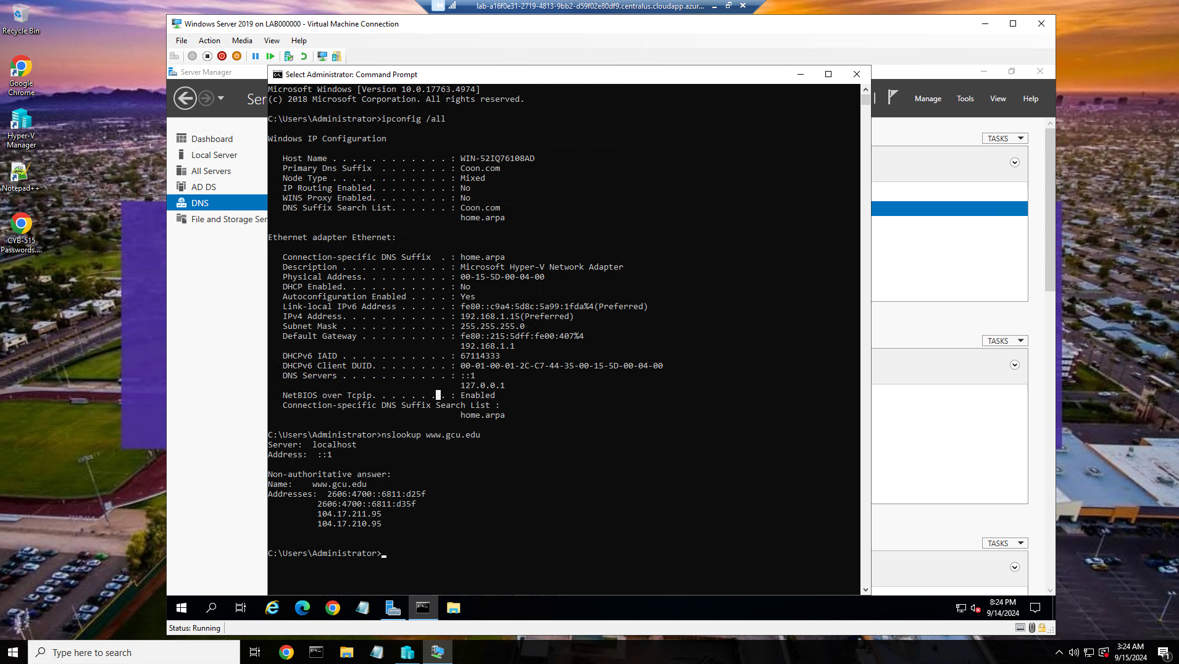

Successful installation of AD. Notice DNS suffix of Coon.com

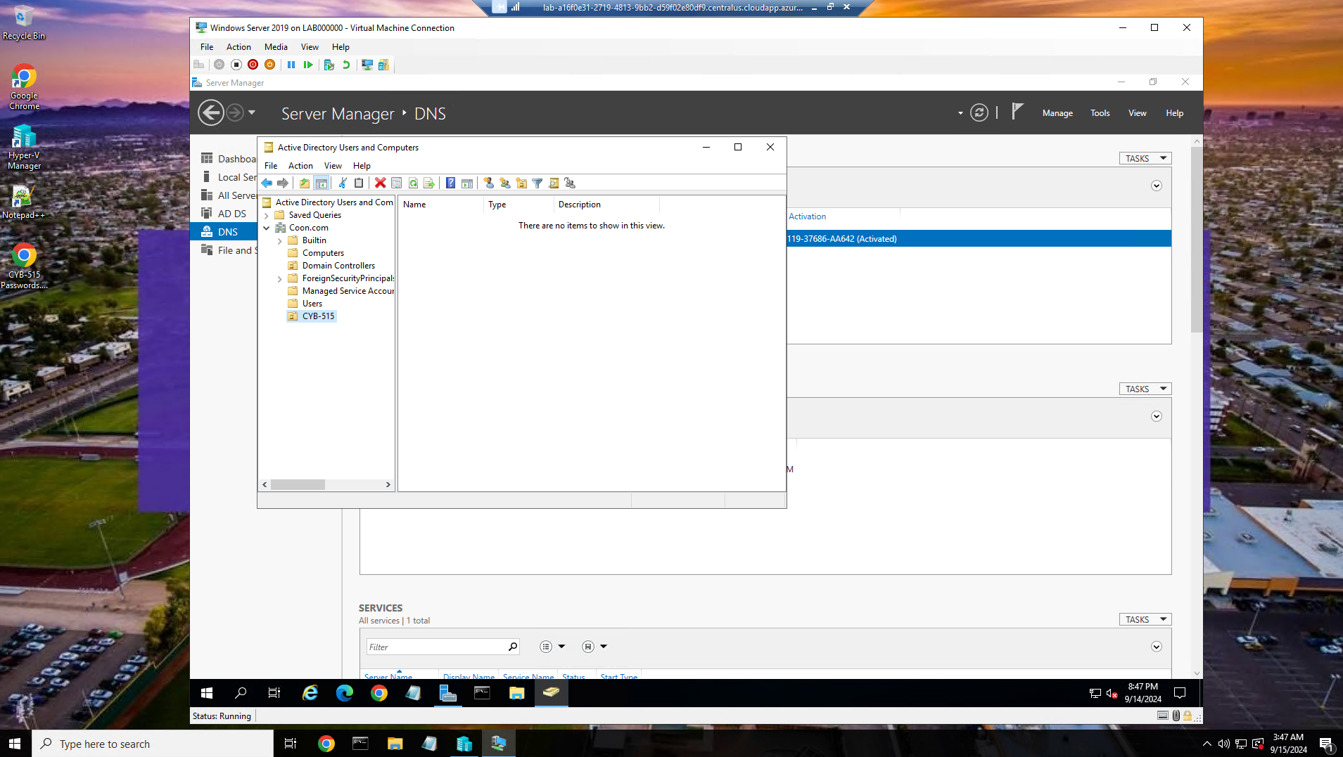

Successful creation of an Organizational Unit named CYB-515 within the root domain.

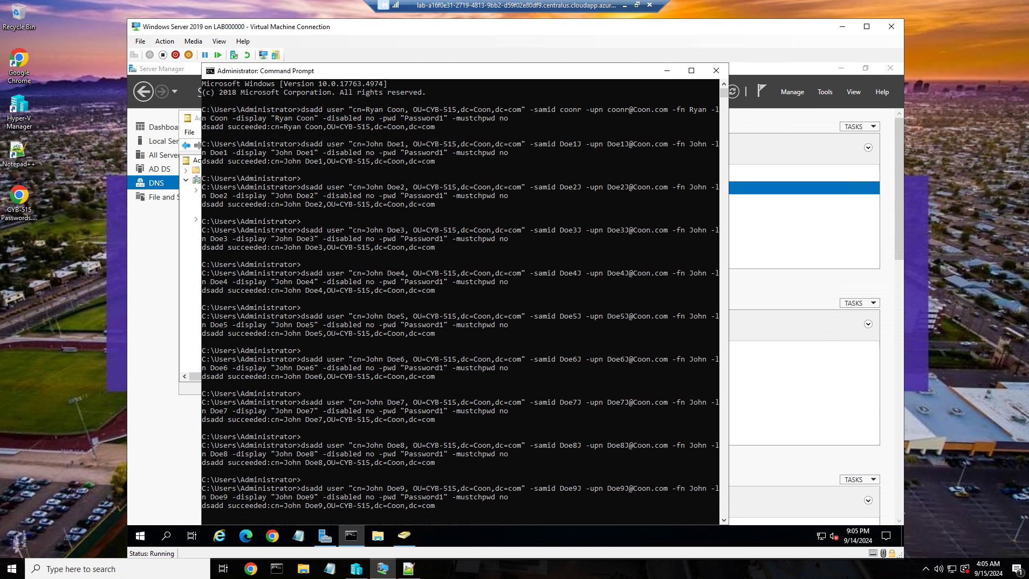

Successful creation of 10 users inside the CYB-515 Organizational Unit using Command Prompt. 1st user is created with my first and last name.

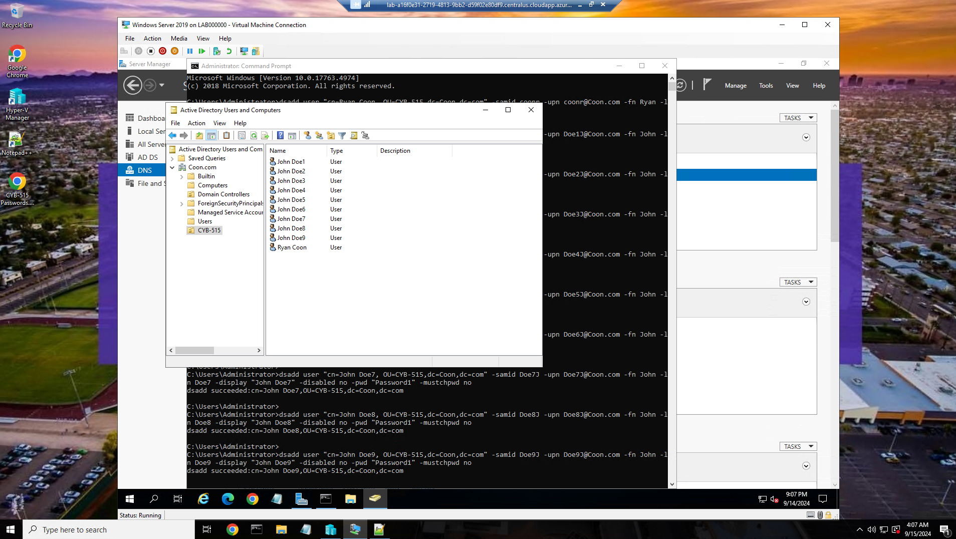

Better visual of users added into the CYB-515 Organizational Unit.

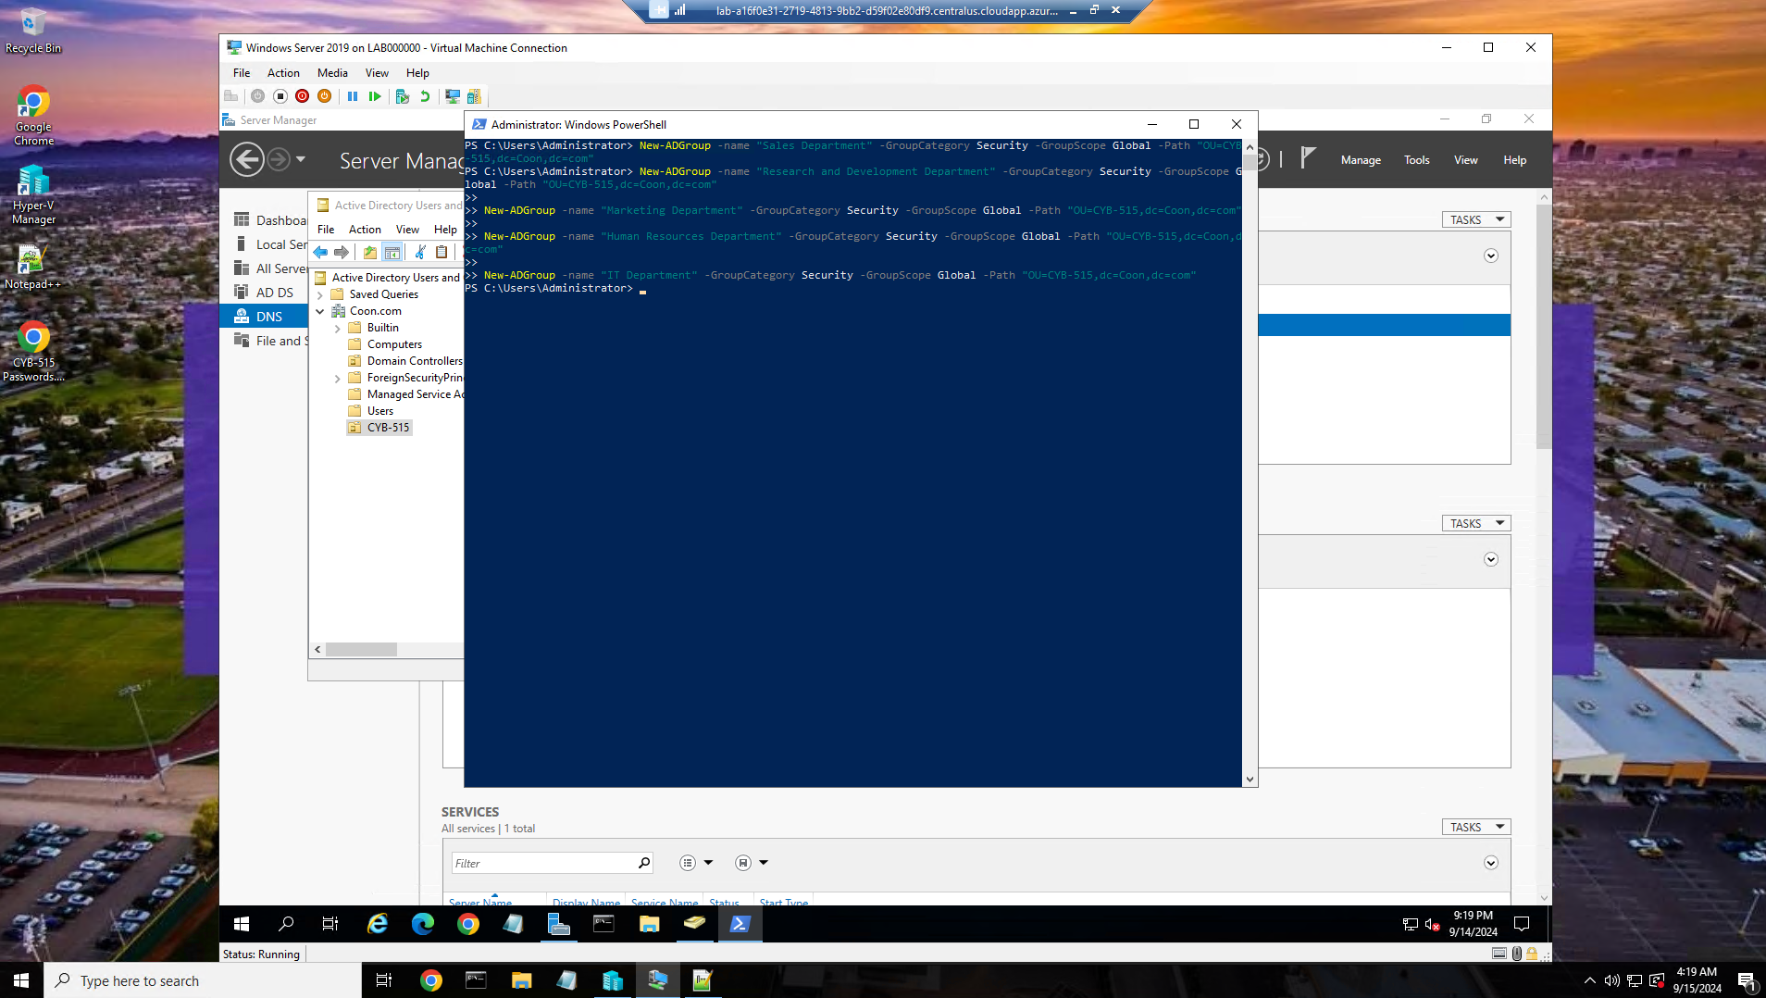

Successful addition of the 5 predetermined groups into the CYB-515 Organizational Unit using Power Shell

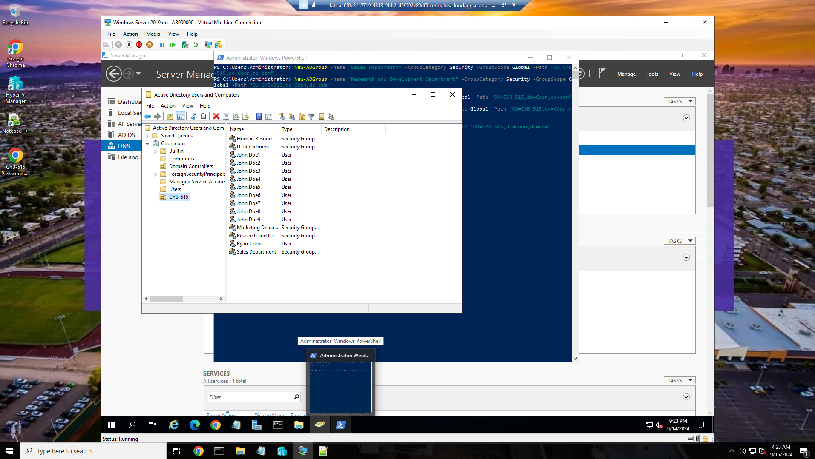

Better visual of the groups that were added.

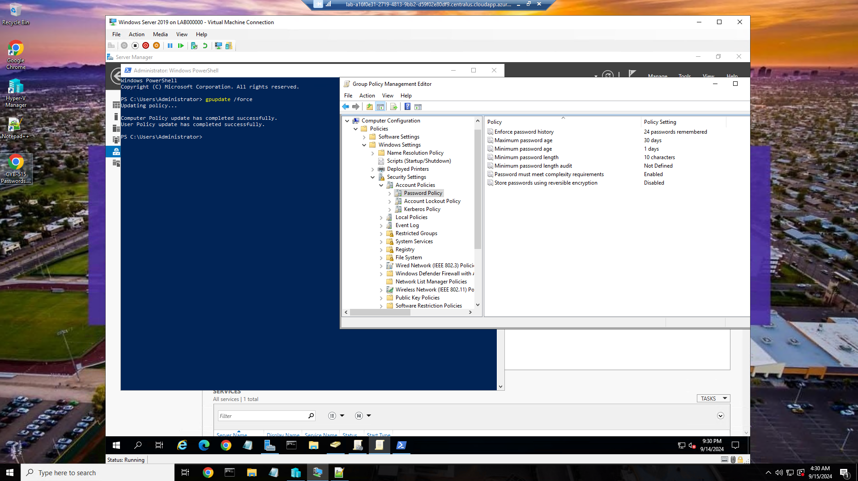

Implemented custom password policies to the Active Directory for the 5 groups in the Coon Domain

Part 2:

**Identify vulnerabilities and risks to an organization's critical infrastructure if access control is not implemented.**

If access control mechanisms are not implemented, organizations face significant vulnerabilities and risks to their critical infrastructure. These may include unauthorized access, data integrity issues, service disruptions, and compliance violations. Without proper controls, malicious actors can gain access to sensitive systems and data, leading to potential data breaches, theft, or sabotage. In the absence of access controls, unauthorized users may alter or corrupt critical data, undermining the integrity of operations and decision-making. Attackers can disrupt services, leading to operational downtime, financial loss, and damage to reputation. Lack of access control can result in non-compliance with industry regulations, leading to legal repercussions and financial penalties.

**Describe why each principle of access control is important to security and how it enables the development of security mechanisms that can implement desired security policies, as it relates to Active Directory.**

The principles of access control are Authentication, Authorization, Accountability, and Auditing and are crucial for security within an Active Directory.

Authentication - Establishes the identity of users trying to access the system. It ensures that only legitimate users can gain access, thereby preventing unauthorized access.

Authorization - Determines what authenticated users are allowed to do. This ensures that users only have access to the resources necessary for their roles, thereby minimizing the risk of data exposure.

Accountability - Involves tracking user activities through logs. This principle ensures that actions can be traced back to users, which deters malicious behavior and aids in investigations.

Auditing - Regularly reviewing access logs and permissions helps identify anomalies and potential security breaches, allowing organizations to respond proactively.

**Analyze workstations, servers, appliances, mobile devices, and/or peripheral devices in an enterprise network. Identify two common security failures and the specific design principles that have been violated.**

Two common security failures include:

Weak Password Policies - This violation of the Security Principle of Least Privilege allows users to access more than they need, increasing the risk of unauthorized entry.

Inadequate Patch Management - Failing to update software can lead to vulnerabilities being exploited. This violates the Defense in Depth principle, as layered security measures are not properly maintained.

Describe the basic security implications of modern computing environments.

Discuss how to develop efficient and effective system solutions to safely secure digital assets and intellectual property.

Describe four hardware components of modern computing environments and discuss the individual functions of each component. Explain which would be the easiest to secure and why.

Identify the secure design principles involved or needed in the creation of user accounts while ensuring the principle of least privilege.

Explain how virtualization is different in the Windows and Linux operating systems.

Basic Security Implications of Modern Computing Environments

Modern computing environments introduce several security implications, including:

Increased Attack Surface: With the proliferation of devices and cloud services, there are more entry points for attackers.

Data Breaches: The potential for sensitive data exposure has increased due to poor security practices and unregulated data sharing.

Complexity of Management: Managing security across diverse platforms and devices complicates the implementation of consistent security policies.

Developing Efficient Security Solutions

To develop efficient and effective system solutions for securing digital assets and intellectual property, organizations should:

Implement Role-Based Access Control (RBAC): This allows for assigning permissions based on user roles, thereby minimizing unnecessary access.

Regularly Update and Patch Systems: Ensuring that all systems are up-to-date reduces vulnerabilities.

Conduct Security Audits: Regular assessments enable organizations to identify weaknesses and improve security measures.

Hardware Components of Modern Computing Environments

Four key hardware components include:

Processors (CPUs): Execute instructions and perform calculations. They are essential for the overall performance of a system.

Memory (RAM): Temporarily stores data and instructions for quick access. It is critical for system speed and responsiveness.

Storage Devices (HDD/SSD): Store data permanently. SSDs are generally faster and more reliable than HDDs.

Network Interface Cards (NICs): Enable communication between devices on a network. They are crucial for connectivity and data transfer.

Among these, Storage Devices are often the easiest to secure due to the ability to implement encryption and access controls at the storage level.

Secure Design Principles for User Accounts

When creating user accounts, the following secure design principles should be applied:

Principle of Least Privilege: Users should only have access to the information necessary for their work.

Segregation of Duties: Tasks should be divided among multiple individuals to reduce the risk of fraud or error.

Regular Review of Permissions: Periodic audits of user access rights help ensure compliance with security policies.

Virtualization in Windows and Linux

Virtualization differs significantly between Windows and Linux operating systems:

Windows: Primarily uses Hyper-V for virtualization, which integrates tightly with Windows Server and offers features like live migration and virtual machine replication.

Linux: Utilizes KVM (Kernel-based Virtual Machine) and other hypervisors like Xen and VMware, allowing greater flexibility and efficiency in resource allocation.

Overall, both systems provide robust virtualization solutions, but they cater to different administrative preferences and environments.

In summary, implementing effective access control mechanisms and adhering to security principles are paramount for safeguarding an organization’s critical infrastructure and digital assets. By understanding vulnerabilities, analyzing devices, and applying secure design principles, organizations can significantly enhance their cybersecurity posture.